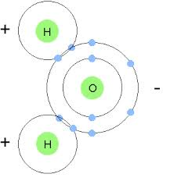Chapter 9 – Water

(H2O) Water molecule is an example of **covalent bonding**.

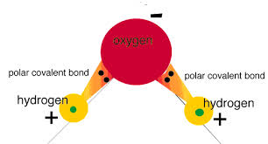**Polar Covalent Bonds** – a molecule with a clear division of opposite electrical charges.

*Electronegativity* – measure of how strongly an atom

Attracts electrons in a chemical bond.

**Hydrogen Bonds** – an attractive force between any molecules in which hydrogen is covalently bound to a highly electronegative element.

Properties of Water

Water is the **medium** – a substance through which something is transmitted or carried for every chemical reaction that sustains life.

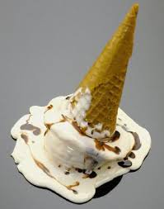Freezing and Melting

Melting point – a point at which a substance changes from a solid to a liquid.

Heat of Fusion

**Latent heat** – the energy required to cause a phase change.

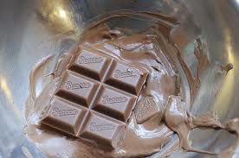 **Heat of fusion** – Energy needed to change 1.0g of a substance from solid to liquid phase. When the situation is reversed, and the liquid phase becomes a sold, this heat energy is released.

**Heat of vaporization** – the amount of heat needed to

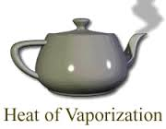change 1.0g of a substance from the liquid phase to the gas phase.

**Sublimation** – a change from the solid phase directly into the gas phase

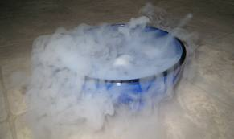

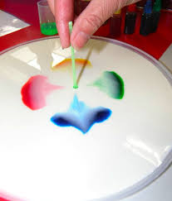 **Surface tension** – inward force that tends to minimize the surface area of a liquid.

Water in Foods

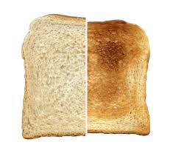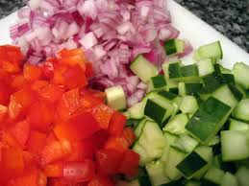**Free water** – readily separates from foods that are sliced, diced, or dried

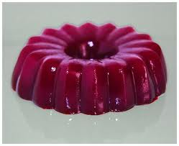 **Bound water** – cannot be easily separated in food.

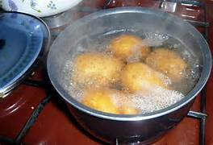Water in **Heat Transfer**

Water is the **medium** to cook the potatoes.

Water as a **Solvent**

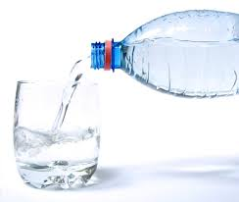 **Solvent –** a substance that dissolves another substance.

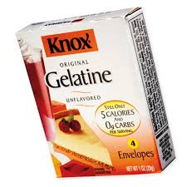**Solute** – a substance that is dissolved

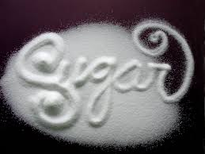

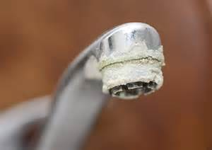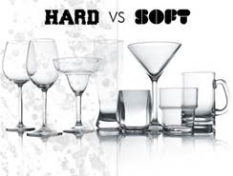**Hard Water** – contains calcium or magnesium ions

****Water as a **Dispersing Medium**

**Colloidal dispersion –** a homogeneous mixture that is not a true solution, contain relatively large solute particles.

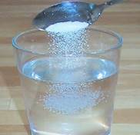 **Colloids –** large particles that don’t disperse completely in a solution

**Emulsion** – common colloidal dispersion, mixture of two liquids containing droplets hat don’t normally blend with each other.

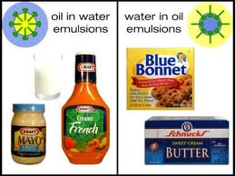

**Immiscible** – liquids that don’t blend or mix

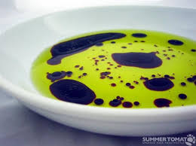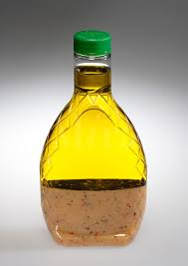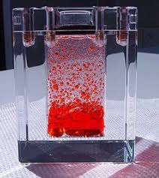

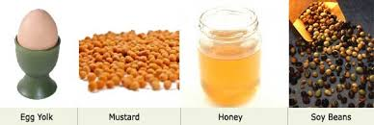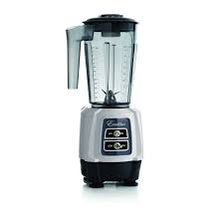**Emulsifier** – a substance composed of large molecules that are polar at one end and nonpolar at the other. Polar end is attracted to water while the nonpolar molecule such as oil.

Water and the Body

65% or more of your weight is water

Percentages depend on fat, bone, and muscle

Water is obtained through food and liquid consumed

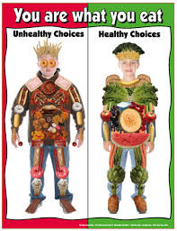Regulates body temperature